Neuron & Neuron Shapes Labeling Activity

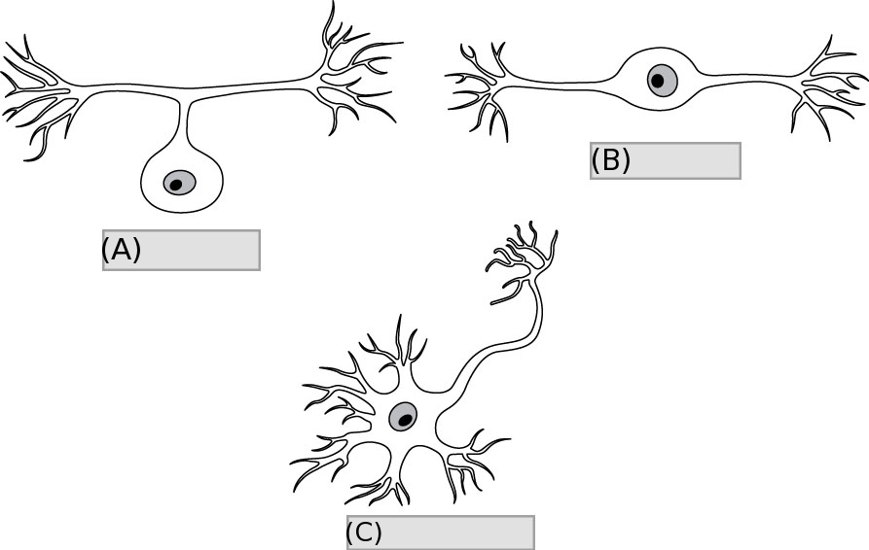

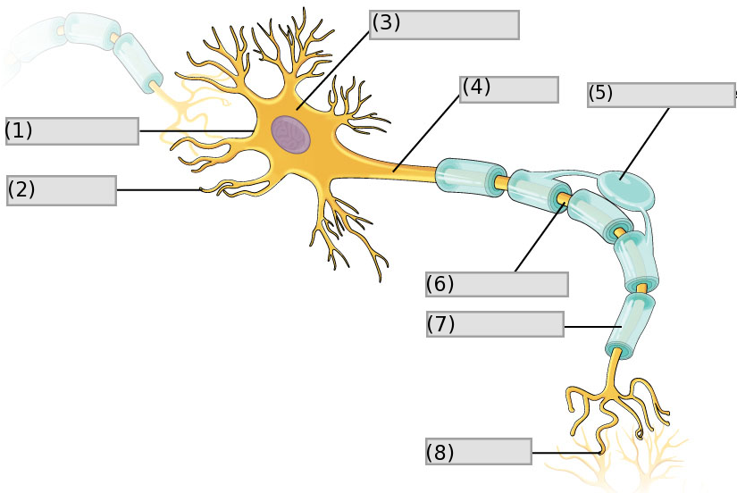

Word bank

1. Multipolar
2. Anaxonic
3. Bipolar
4. Unipolar
5. Oligodendrocyte
6. Cell Body (perykaryon)
7. Cell Membrane
8. Synapse
9. Nodes of Ranvier
10. Axon
11. Dendrites
12. Myelin sheath

Answer Key

1. Unipolar
2. Bipolar
3. Multipolar
4. Cell membrane
5. Dendrites
6. Cell body(perykaryon)
7. Axon
8. Oligodendrocyte
9. Nodes of Ranvier
10. Myelin sheath
11. Synapse